ISO 21090 Common Library
ISO 21090 Common Library v2.2
Design Document

Version No: 1.0
Last Modified: 07/13/2010

Author : Vijay Parmar
Team : caCORE SDK
Client : National Cancer Institute - CBIIT
National Institutes of Health,
US Department of Health and Human Services

Document History

Document Location
The most current version of this document is located in SVN under https://ncisvn.nci.nih.gov/svn/ISO21090/trunk/documents/design_documents

Revision History
Version Number | Revision Date | Author | Summary of Changes
0.1 | 07/13/2010 | Vijay Parmar | Initial Draft

Review
Name | Team/Role | Version | Date Reviewed | Reviewer Comments

Related Documents
More information can be found in the following related documents:

Document Name
ISO 21090 Data Types - GAP Analysis: Specifications and Localized Common Library Support
ISO Datatype Support Scope Document
Policy_Guidelines_ISO_21090_Final Approved.doc

Table of Contents

1. Introduction 4
1.1 Problem Scenario 4
1.2 Scope 5
2. Requirement Analysis 5
2.1 Deliverables 5
2.1.1 ISO21090 Java Library 5
2.2 Requirements 5
2.2.1 Business Requirements 5
2.2.2 Technical Requirements 5
2.2.3 Release Non-Functional Requirements 5
2.2.4 Policy Requirements 6
2.3 Assumptions 6
2.4 Dependencies 6
2.5 Known Issues or Future Considerations 6
2.6 Technical Environment 6
3. Detail Design 7
3.1 Overview 7
3.2 Components of Common Library 7
3.3 Source Code 8
3.4 Database Design 9
3.5 Deployment 9
4. Unit Testing 9
4.1 JUnit Test Cases 9
4.2 Test Case Scenarios 10

Introduction

The ISO 21090 Healthcare data types standard provides a set of data type definitions for representing and exchanging basic concepts that are commonly encountered in healthcare environments in support of information exchange in the healthcare environment, [and] specifies a collection of healthcare related data types suitable for use in a number of health-related information environments.

One goal of caBIG® is to provide interoperability between systems. The focus of that interoperability has been facilitating information sharing between data systems. While caBIG tools also support analytical systems, the toolset did not until now support the kind of complex datatypes required by analytical systems to work more efficiently with the healthcare data being made available

NCI CBIIT has adopted ISO 21090 in support of the CBIIT vision of creating healthcare tools that interoperate. The NCI CBIIT ISO 21090 Localization Common Library is a specialized and constrained version of ISO 21090 health care data types. The Localization is the list of approved ISO 21090 data type that will be maintained by NCI CBIIT.

NCI CBIIT ISO 21090 Localization Common Library is Specialized/constrained version of the ISO 21090 Healthcare Data Types. Localization is the list of approved ISO 21090 data types that will be maintained by CBIIT, along with common implementation artifacts. Localization provides indirect conformance to ISO 21090 Healthcare data types by:
- Providing mappings between internal data types and the healthcare data types
- Specifying for which of the data types an inward mapping is provided, which an outward mapping is provided, and for which no mapping is provided
- Specifying whether the XML representation described herein is used when the data types are represented in XML, or optionally to provide an alternative namespace for the XML representation

Problem Scenario

The Patient Outcomes Data Service (PODS) currently utilizes a custom implementation of a localization of the ISO 21090 data types. This localization provides the capability to serialize to, and deserialize from, the canonical XML representation (as defined by the ISO XML Schema) for the purposes of transport on the grid. Use of this implementation in clients and other implementations is non-trivial, and needs to be supported by caBIG® infrastructure and tooling.

Longer term, more complete localizations may be required to facilitate other use cases or domain usage and a similar, but more comprehensive, solution will be required. Additionally, the full impact of their use on the semantic infrastructure needs to be evaluated, and may introduce additional requirements.

Scope

This document details the design of the NCI CBIIT ISO 21090 Common Library for version 2.2. It provides detail design of the extension to the existing common library API. This document doesn’t provide design details about the integration with other infrastructure tooling components. The infrastructure tooling support details are beyond the scope of this document.

Requirement Analysis

Deliverables

ISO21090 Java Library
An independent software project will be developed by a cross-project team, in support of the following:

- Java Beans for Localization
- Serialization support for to/from those Beans to standard ISO XSD
- Hibernate support for ORM mapping those Beans to database

Requirements

Business Requirements
- Enable ISO 21090 Tooling Support

Primary objective of this project is to establish ISO 21090 compatible infrastructure along with comprehensive ISO 21090 enabling and supporting tools. The developed infrastructure should be ready to be adopted by any organizations to establish their own health information system, or to be integrated with nationwide BIGHealth system.

Technical Requirements

- Enhance the existing library
Enhance existing library to support additional data types and their attributes from ISO 21090 specifications not supported in the NCI CBIIT Common Library v2.1 release.

Release Non-Functional Requirements

- Open Source

The product will continue to use open source tools and technologies. If an appropriate open source software or tool is not available then prior approval from the product manager will be required before using the tool.

- Technology Stack compatibility

The products will continue to adhere to the CBIIT technology stack when choosing the versions of the tools it’s using. Any deviation from the technology stack will be pre-approved by the product manager.

- Automated builds
The products will continue to support their existing automated build processes.eamless integration of Migration Module with existing web application

Policy Requirements

To be NCI CBIIT ECCF compliant

The NCI CBIIT Enterprise Conformance and Compliance Framework (ECCF) document requires that, in order to achieve Computable Semantic Interoperability (CSI), each attribute of a static information model should be bound to a robust data type specification.

Assumptions
- The ISO 21090 v2.2 implementation is based on assumptions that the additional data type support will be in line with the guidelines and will be approved later.

Dependencies

- ISO 21090 Specifications.

The Common Library depends on the ISO 21090 specifications for XSD schema to perform validations.

- NCI CBIIT ISO 21090 Localization

The Common Library also depends on the NCI CBIIT localization specifications approved the the eCAT. The guidelines are available in this document

Known Issues or Future Considerations

- Localization has an attribute called "Any" used to specify that nothing is known about the interval except that some particular value lies within the interval. In the localization, "Any" is used to populate "High" and "Low" values conditionally. ISO 21090 XSD does not have this attribute. "Any" attribute will not be transmitted during outward mapping.

Technical Environment
- Operating system
  - Windows XP
  - Linux/Unix
- Java 1.5

Detail Design

Overview

An independent software project will be developed by a cross-project team, in support of the following: he overall flow for CGMM is as following
- Java Beans for Localization
- Serialization support for to/from those Beans to standard ISO XSD
- Hibernate support for ORM mapping those Beans to database

The NCI CBIIT ISO 21090 Localization Architectural Overview (https://wiki.nci.nih.gov/x/qjpyAQ) describes the steps between an XML wire representation to a potential database representation and back.

Components of Common Library

The following are the minimum set of components involved in the Migration Module Framework. The following section describes the design for CSM GAARDS Migration Module and integration with Host applications.

- Localization

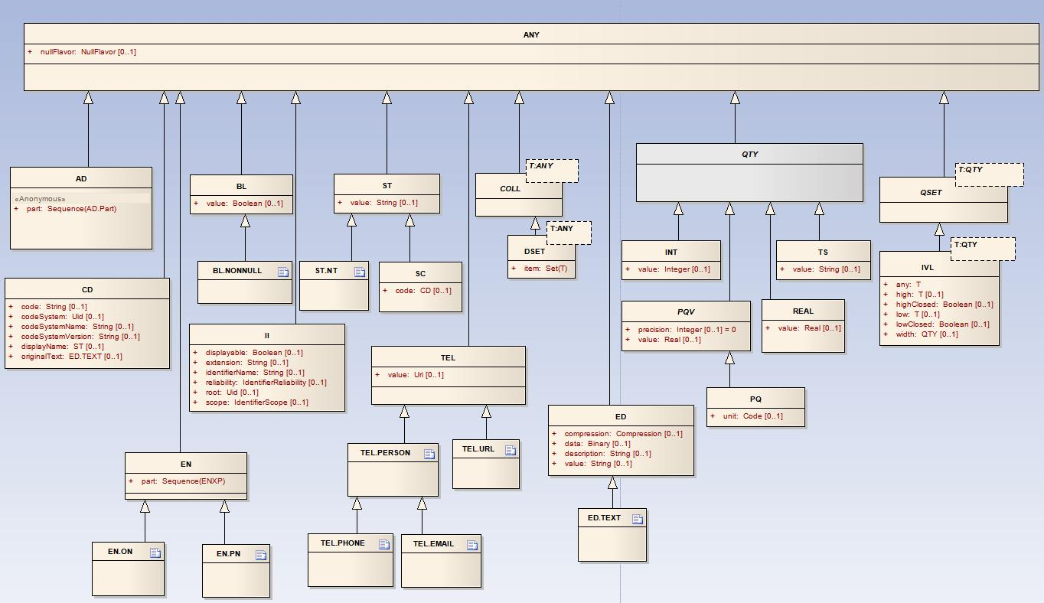
Figure 1

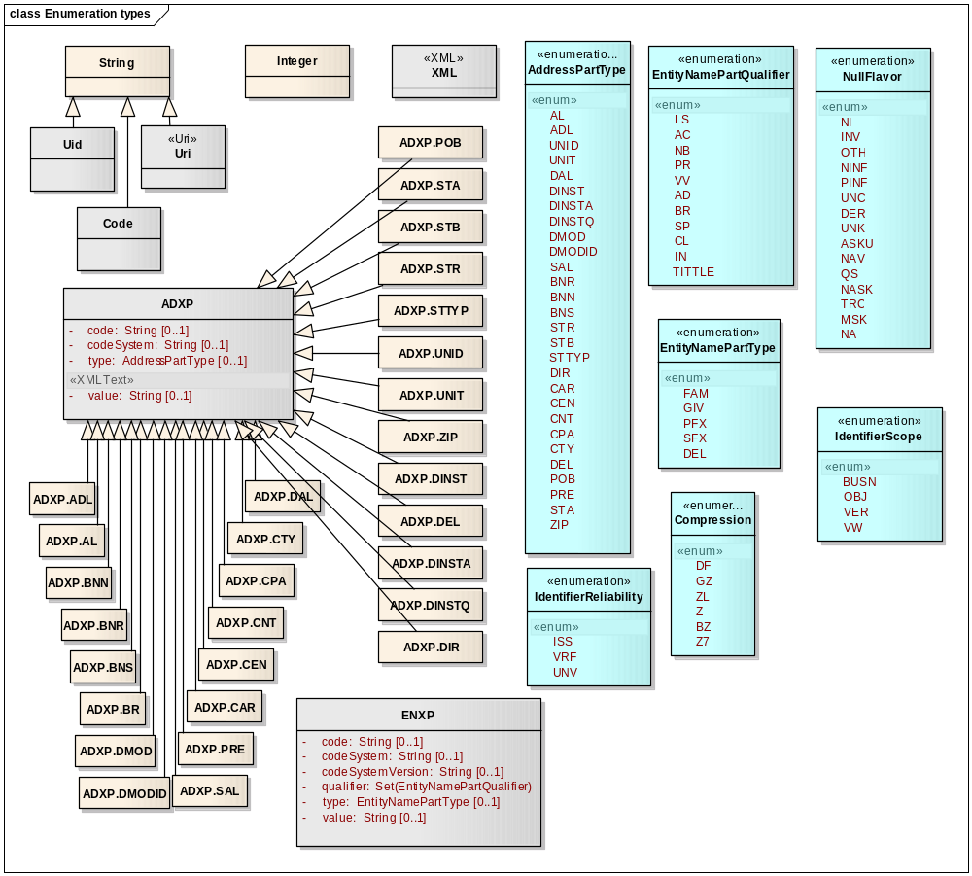
Figure 2
- Extensions

- Hibernate Framework

Source Code

The following is the package structure:

Localization (code\localization\src\main\java\):
-- gov.nih.nci.iso21090

Localization Junit tests (code\localization\src\test\java\):
-- gov.nih.nci.iso21090

Extension(code\extensions\src\main\java):
-- gov.nih.nci.iso21090.grid.dto.transform
-- gov.nih.nci.iso21090.grid.ser

Extension JUnit tests (code\extensions\src\test\java):
-- gov.nih.nci.iso21090.grid.dto.transform
-- gov.nih.nci.iso21090.grid.ser

Hibernate Framework (code\hibernate\src\main\java\):
-- gov.nih.nci.iso21090.hibernate.nodes
-- gov.nih.nci.iso21090.hibernate.property
-- gov.nih.nci.iso21090.hibernate.tuple
-- gov.nih.nci.iso21090.hibernate.usertype

ISO XSD:
-- code\extensions\src\main\xsd\ISO_datatypes_Narrative.xsd
-- code\extensions\src\main\xsd\ISO_extensions.xsd

-- Ant buildfile

-- build.xml

Database Design

The ISO Data type Hibernate Mapping Design and describes the existing Localized Common Library v2.1 database design.

Deployment
No deployment is done. A software distribution consisting of documentation, jar files, XSDs, and configuration files will be provided.

Unit Testing

JUnit Test Cases

The Unit test cases are available for the Localization and Extensions sub projects.

  - Localization Junit tests (code\localization\src\test\java\):
    - Package: gov.nih.nci.iso21090
  - Extension JUnit Tests (code\extensions\src\test\java)
    - gov.nih.nci.iso21090.grid.dto.transform
    - gov.nih.nci.iso21090.grid.ser

Test Case Scenarios
The test case scenarios will be developed in conjunction with the QA Team.. Note that based on data each of these scenarios can have multiple test cases

